People's Day 2018
By Pete Webb

This year's People's Day seemed to be getting back to its roots as a community festival for the people of Lewisham. As I roamed around Mountsfield park in the sweltering heat, I came across the Time Bank stall with Simone enthusiastically encouraging all passing traffic to join. Fay was also working hard promoting Lewisham Local and FoodCycle with the help of several other Time Bank members.

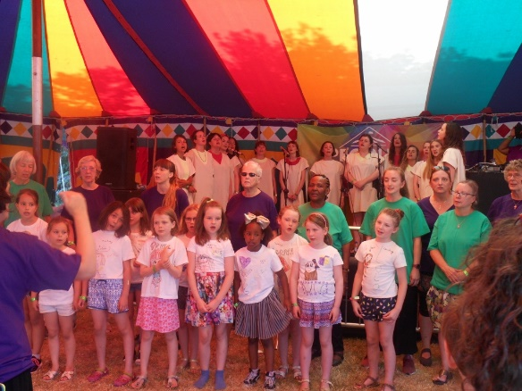
The community stalls area was large this year and included stalls from Community Connections, Voluntary Services Lewisham, Age Concern, The scouts and Carers Lewisham. As the heat was getting to me, I took refuge in the big top where Catford Sound's Marvellous Musical Menagerie were singing songs with animal themes. Quite enjoyable but fairly limited in the material, I decided to check out the Little Big Top in the Green Area.

The excellent Florence Lawrence Chorus were in full voice banging out some great songs, culminating in a collaboration with Trinity Laban on a song called The Wall. This was so good that I didn't think anything else on the day could top it and so I departed from People's day a happy man.

